Lab Objective

Create and modify an Autounattend.xml file using Windows System Image Manager

**Lab Procedures**

**Step 1. Create an Autounattend.xml**

**1.** On Server01, right-click the Start button, select Run \\rwdc01\software then click OK. Copy the ADK folder to C:\Softwarefolder.

**2.** Open the E:\Sources folder and copy the install.wim to the C:\Software folder.

**3.** On Server01, open the C:\Software\ADKfolder.

**4.** To start the installation of the Windows Assessment and Deployment Kit, double-click adksetup.exe. If it asks you to run this file, click Run.

**5.** On the Specify Location page, leave the default settings, and then click Next.

**6.** When you are prompted to join the Customer Experience Improvement Program (CEIP), click Next.

**7.** On the License Agreement page, click Accept.

**8.** Deselect all options except Deployment Tools and Windows Preinstallation Environment (Windows PE) as shown in Fig below. Click Install.

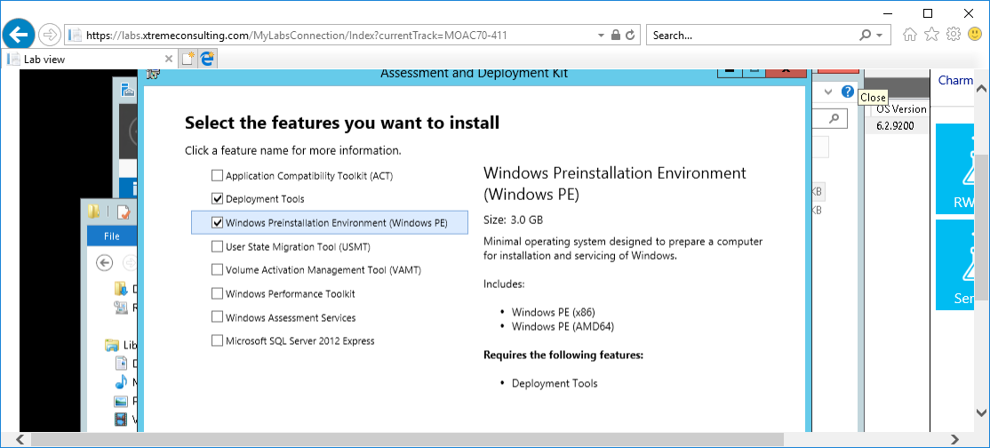

Figure . Deselect all options except Deployment Tools and Windows Preinstallation Environment (Windows PE)

**9.** When the installation is complete, click Close.

**10.** Using File Explorer, create a folder called C:\DistFold.

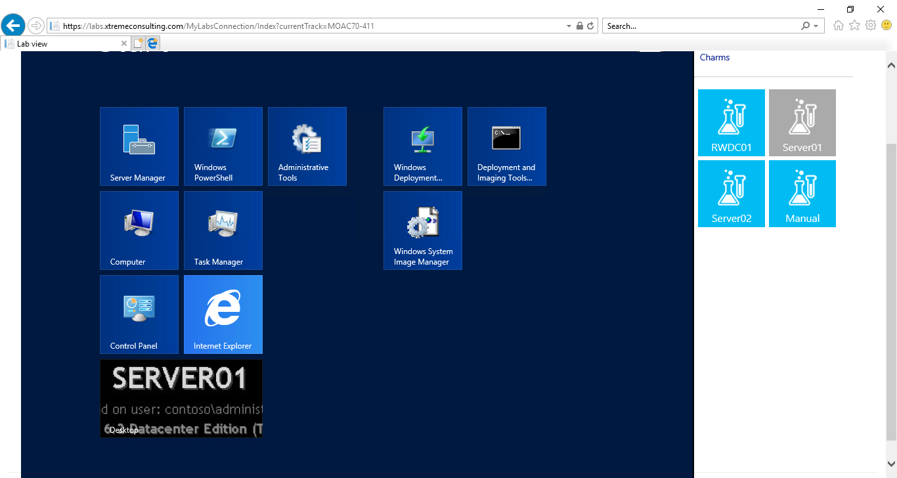**11.** Click Start > Windows System Image Manager as shown below. The Windows System Image Manager console opens

Figure . Select Windows System Image Manager from Start

**12.** Click Tools > Create Distribution Share. The Create Distribution Share dialog box opens.

**13.** In the Folder name text box, type **C:\DistFold** folder and click Open.

**14.** Click File > Select Windows Image. The Select a Windows Image dialog box opens.

**15.** In the file name text box, type **C:\Software\install.wim** and click Open. Click Windows Server 2012 SERVERSTANDARD and click OK.

**16.** If you are prompted to create a catalog file, click Yes.

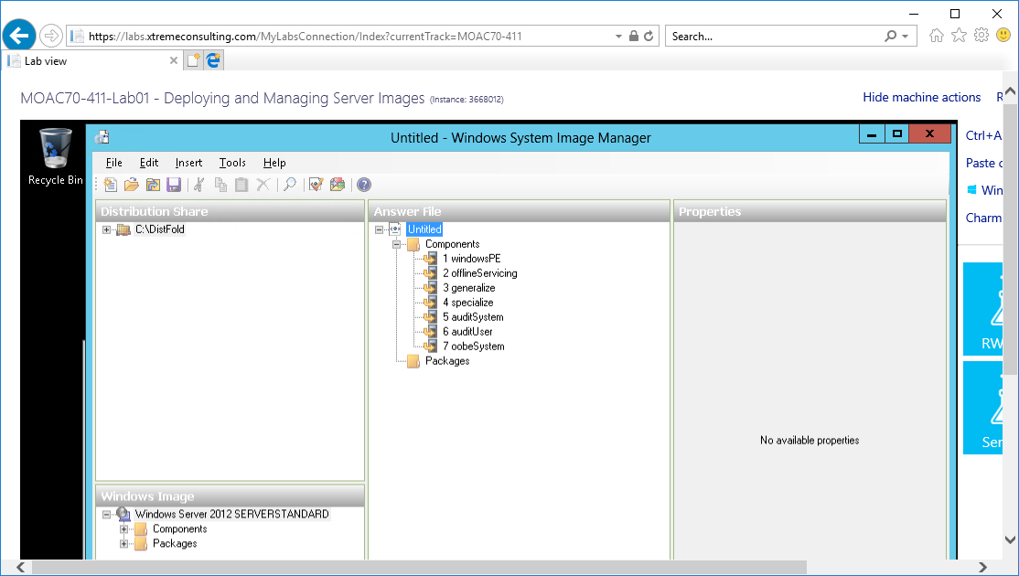**17.** Click File > New Answer File as shown in Fig below. The answer file elements display in the Answer File pane.

Figure display in the Answer File pane.

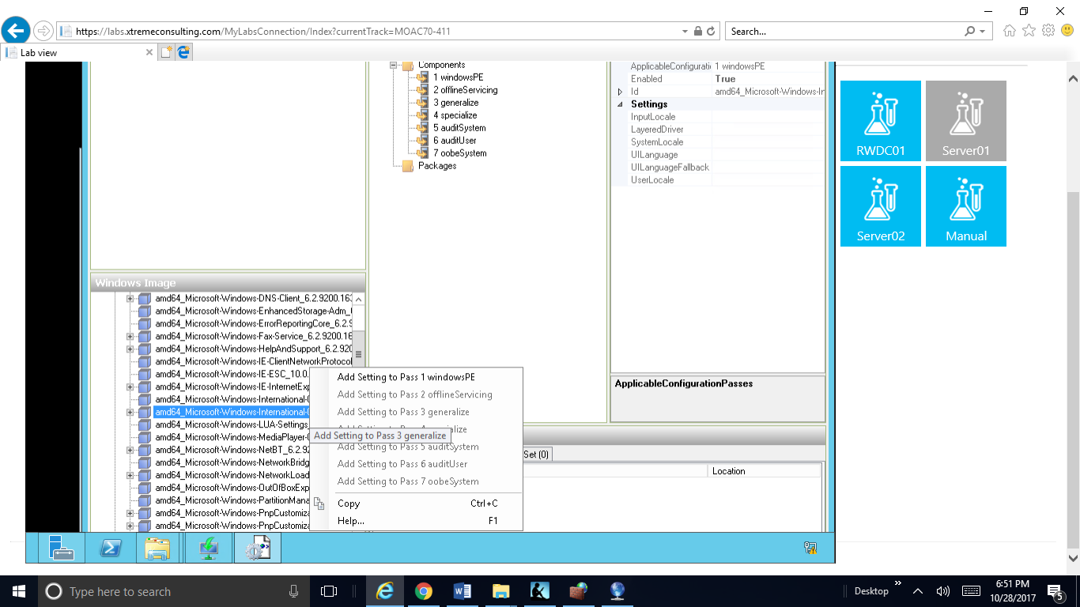

Figure Step 18. In the Windows Image pane, expand Components. Then scroll down and right-click amd64_Microsoft-Windows-International-Core-WinPE_6.2.9200. 16384_neutral and click Add Settings to Pass 1

**18.** In the Windows Image pane, expand Components. Then scroll down and right-click *amd64_Microsoft-Windows-International-Core-WinPE_6.2.9200. 16384_neutral* and click *Add Settings to Pass 1 WindowsPE*, as shown in Figure 1-2.

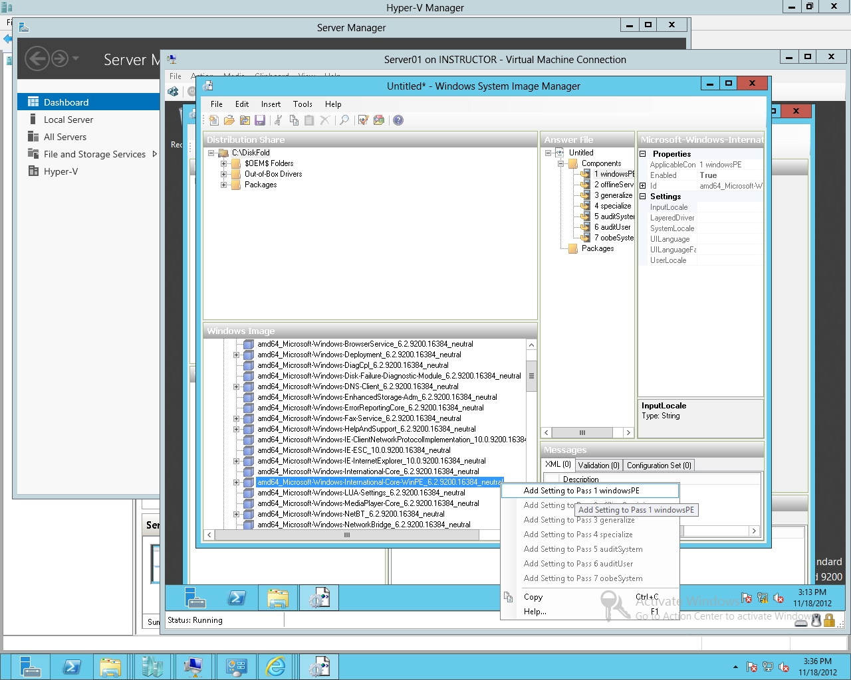

Figure 1-2

Adding Settings to Pass 1 WindowsPE

**19.** The Microsoft-Windows-International-Core-WinPE component specifies the default language, locale, and other international settings to use during Windows Setup or Windows Deployment Services installations. In the Answer File pane click *amd64_Microsoft-Windows-International-Core-WinPE_neutral*, and fill in the language settings as shown in Figure 1-3 as appropriate, such as **en-US**.

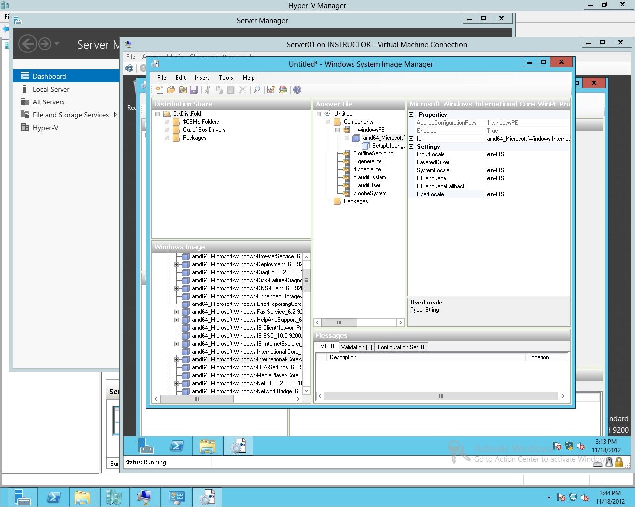

Figure 1-3

Specifying language settings

**20.** Expand *amd64_Microsoft-Windows-International-Core-WinPE_neutral* and click SetupUILanguage.Type **en-US** in the properties for UILanguage.

**21.** The Microsoft-Windows-Setup component contains settings that enable you to select the Windows image that you install, configure the disk that you install Windows to, and configure the Windows PE operating system. Under the Windows Image pane, right-click *amd64_Microsoft-Windows-Setup_6.2.9200.16384_neutral*, and click *Add Setting to Pass 1 windowsPE*.

**22.** In the Answer File pane, expand *amd64_Microsoft-Windows-Setup_neutral,* right-click DiskConfiguration, and select Insert New Disk, as shown in Figure 1-4.

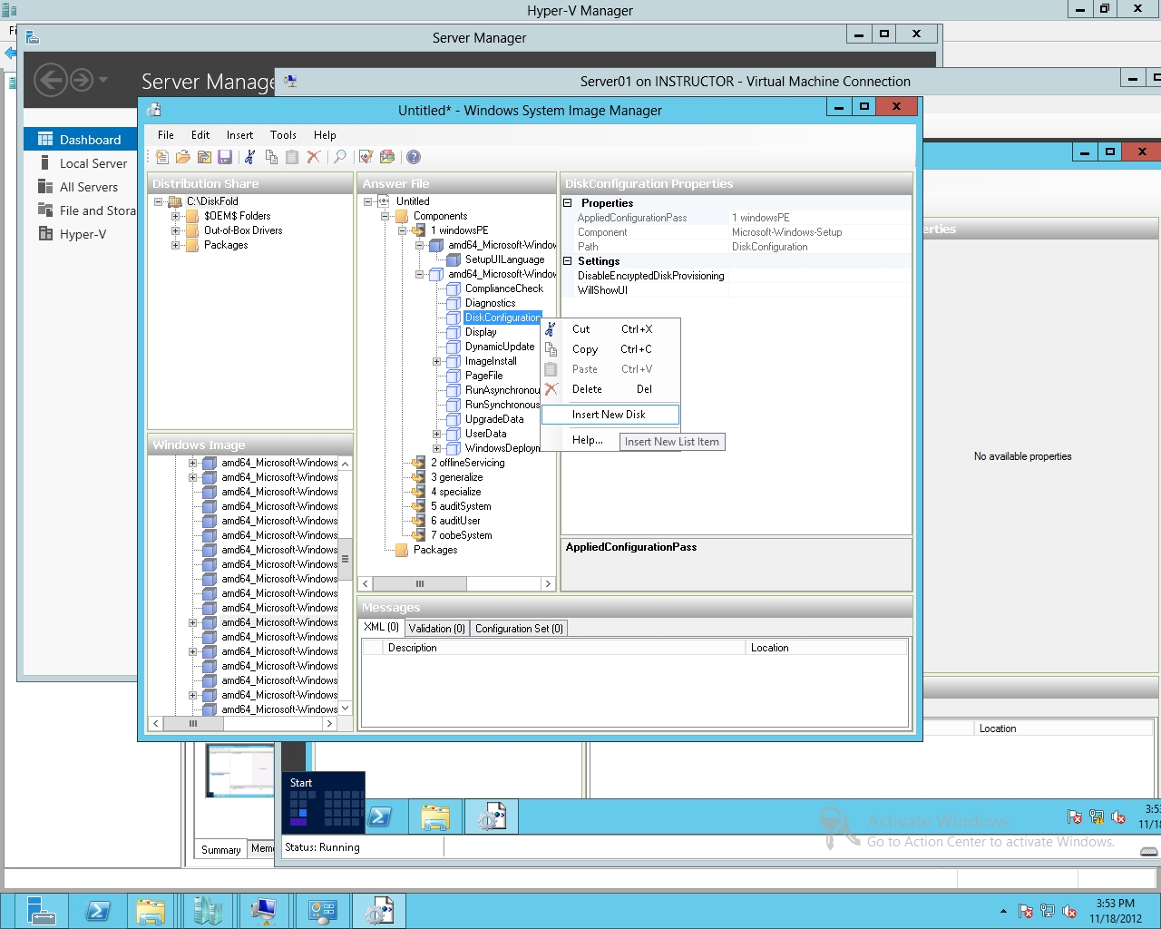

Figure 1-4

Inserting New Disk

**23.** In the Answer File pane, expand *amd64_Microsoft-Windows-Setup_neutral*, expand Disk, right-click CreatePartitions, and select Insert New CreatePartition.

**24.** Specify the order of **1**, size of **350**, and type of **Primary**, as shown in Figure 1-5.

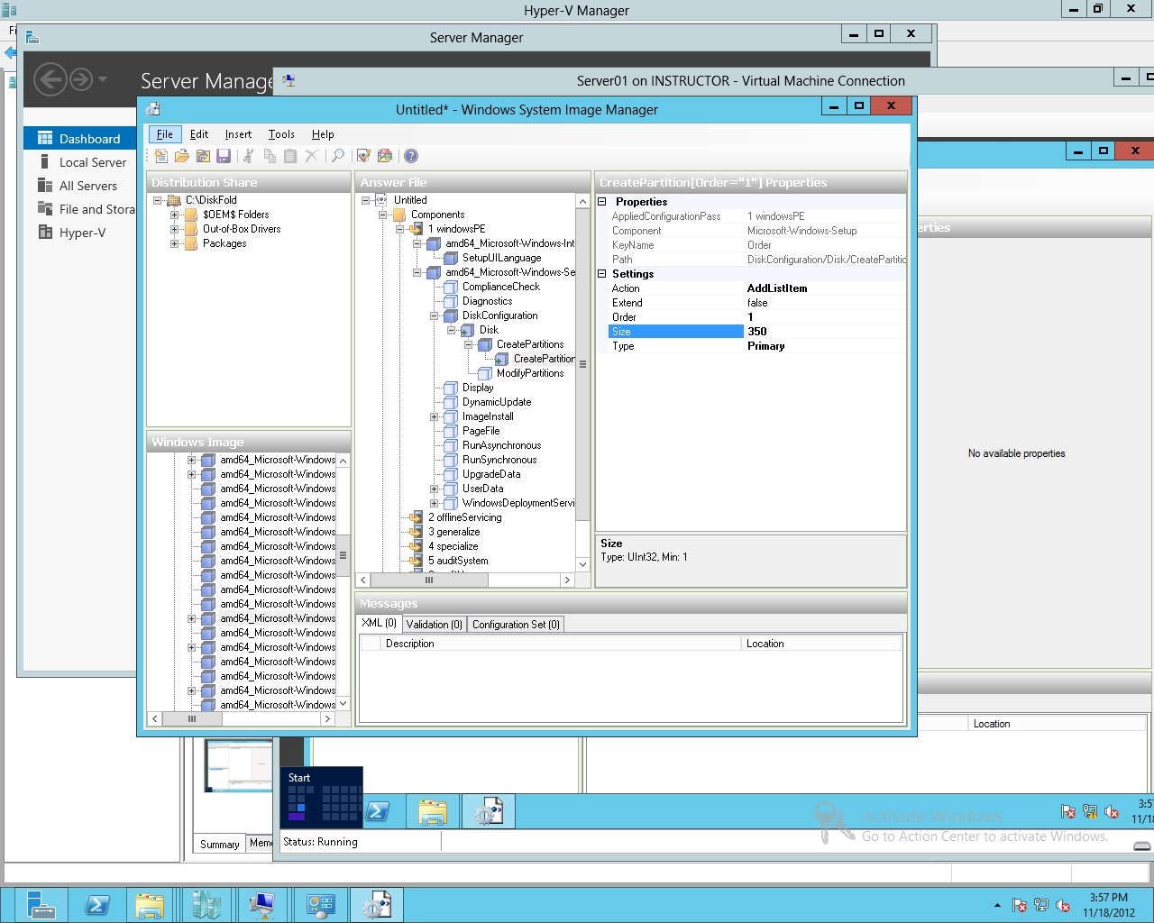

Figure 1-5

Specifying size of a partition

**25.** Right-click CreatePartitions and click Insert New CreatePartition. For the new CreatePartition entry, change the Extend property to true and set Order to **2**. Don’t configure the size, as shown in Figure 1-6.

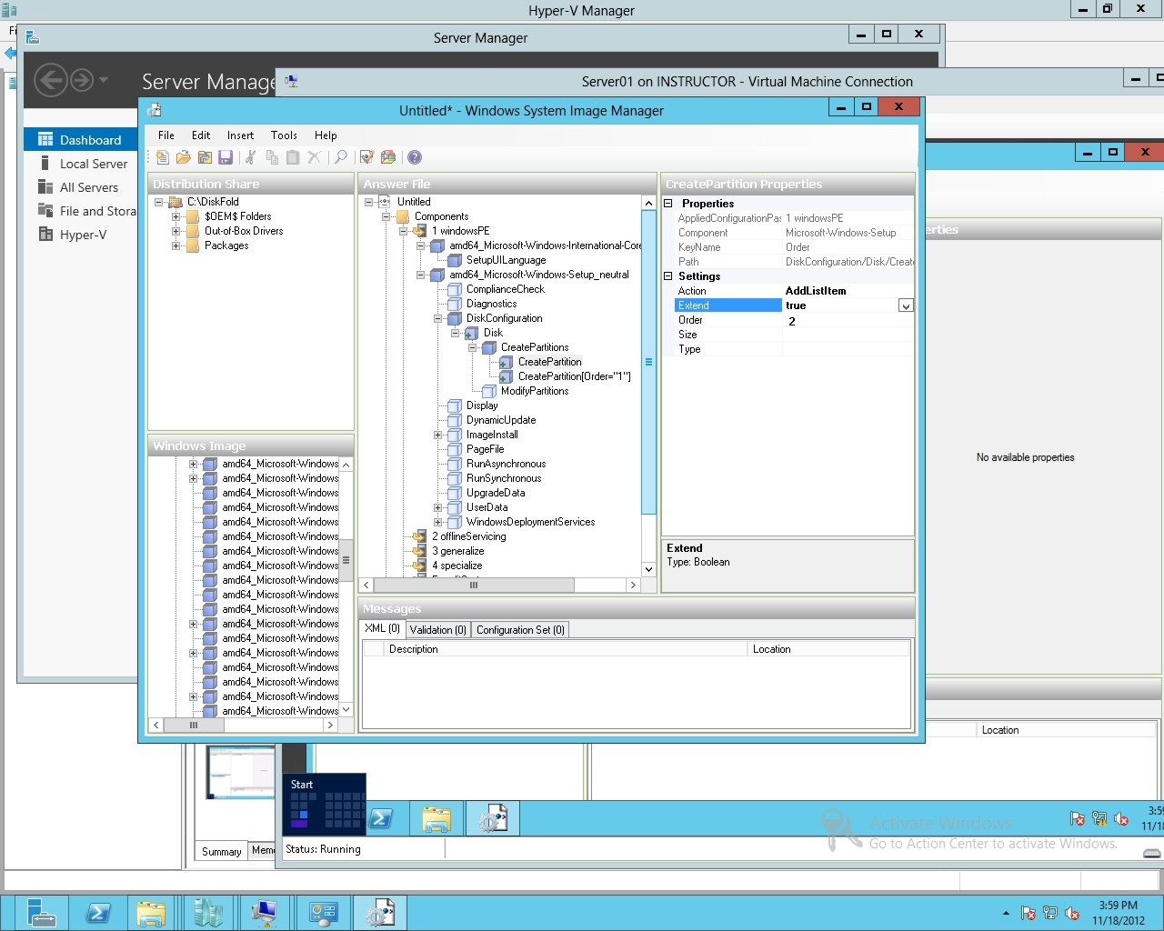

Figure 1-6

Extended a partition

**26.** In the Answer File pane, click Disk, then change the DiskID to **0** and WillWipeDisk to true, as shown in Figure 1-7.

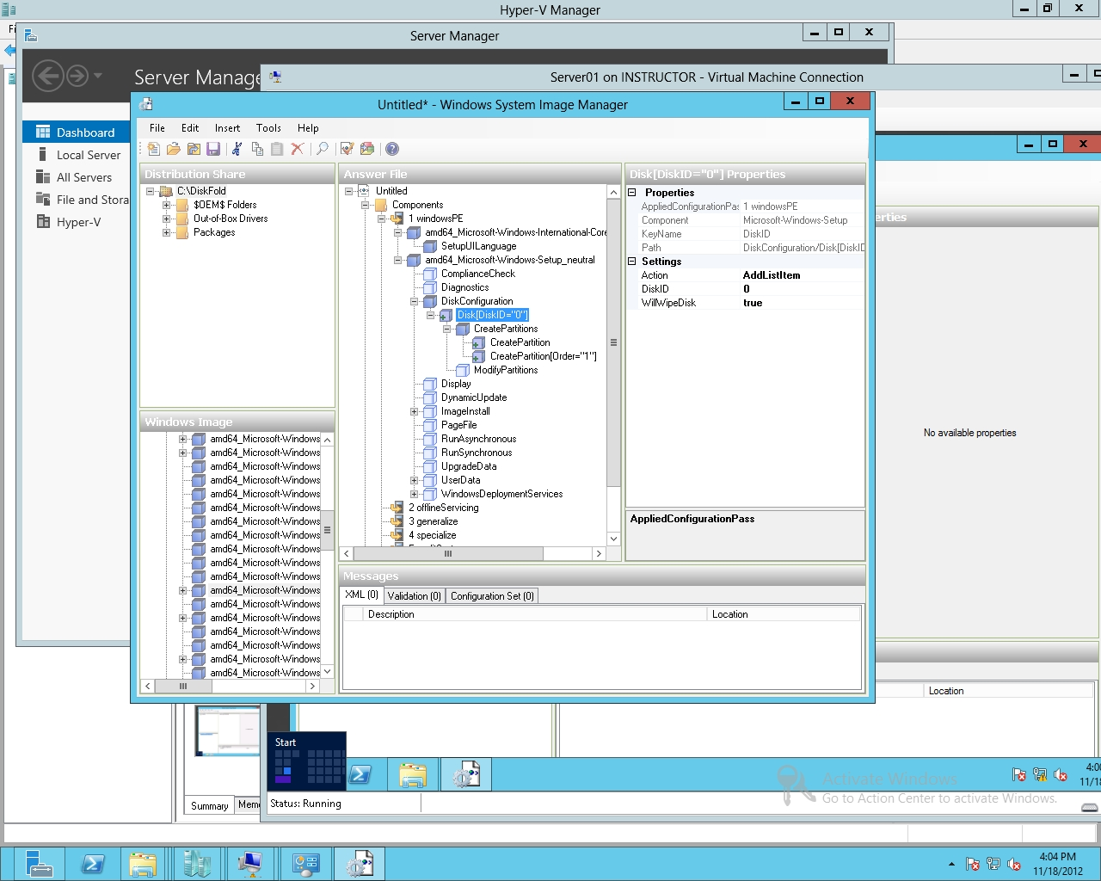

Figure 1-7

Specifying the DiskID

**27.** Right-click ModifyPartitions and select Insert New ModifyPartition. Then specify the following, as shown in Figure 1-8:

Active is **true**

Format is **NTFS**

Label is **Boot**

Order is **1**

PartitionID is **1**

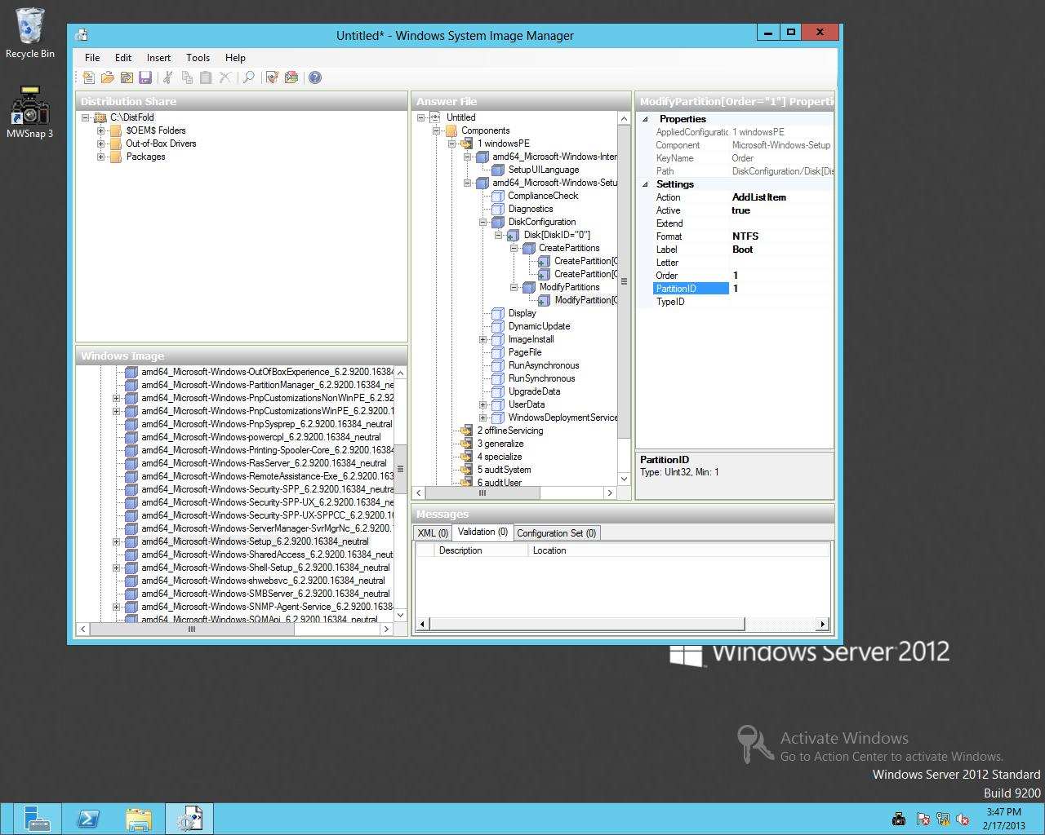

Figure 1-8

Specifying the Partition ID

**28.** Add a second ModifyPartitions and configure as the following:

Format is **NTFS**

Label is **System**

Order is **2**

PartitionID is **2**

**29.** In the Answer File pane, scroll down to and expand ImageInstall. Expand OSImage and right-click InstallFrom and select Insert New Metadataand configure the metadata as shown Figure 1-9.

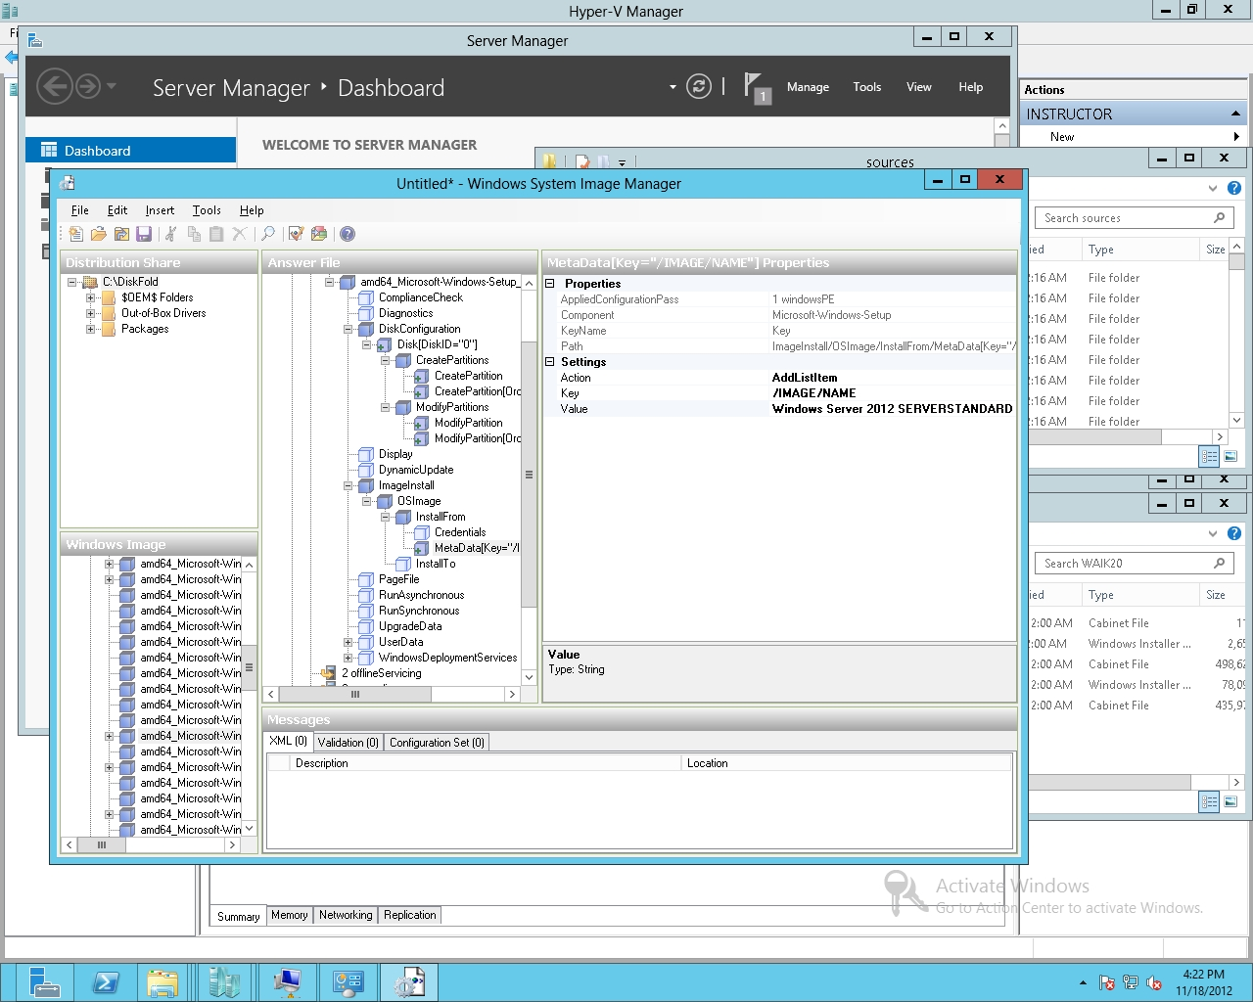

Figure 1-9

Specifying Which Image to Use

**30.** Click InstallTo and configure the DiskID to **0** and PartitionID to **2**, as shown in Figure 1-10.

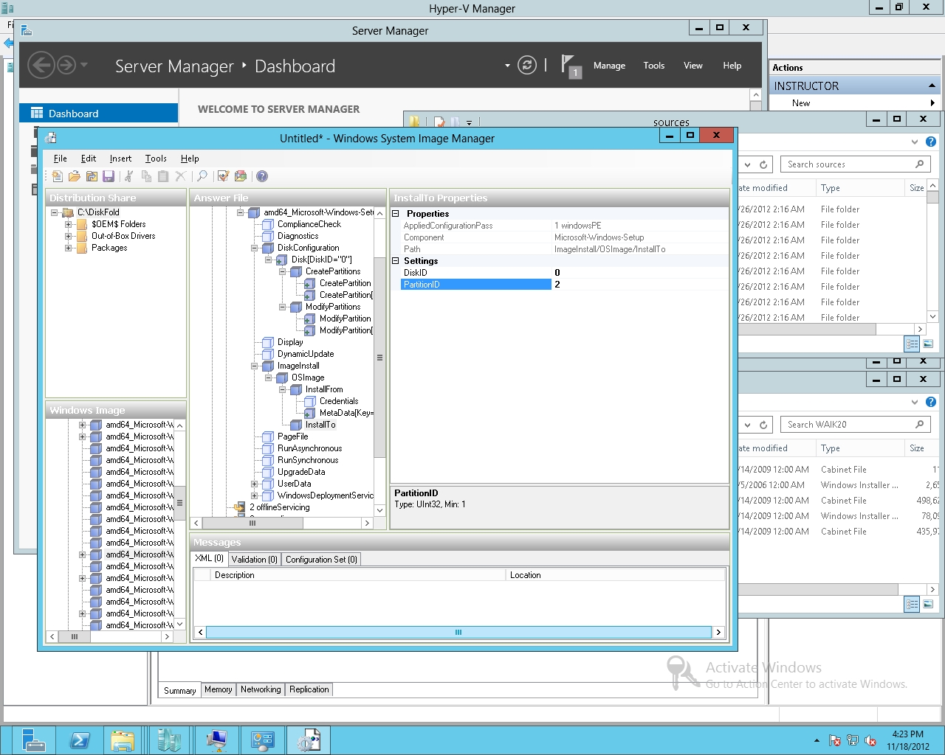

Figure 1-10

Specifying which disk and partition to install to

**31.** In the Answer File pane, click UserData. Then specify the following:

Accept EULA to **true**

FullName to **Student**

Organization to **Classroom**

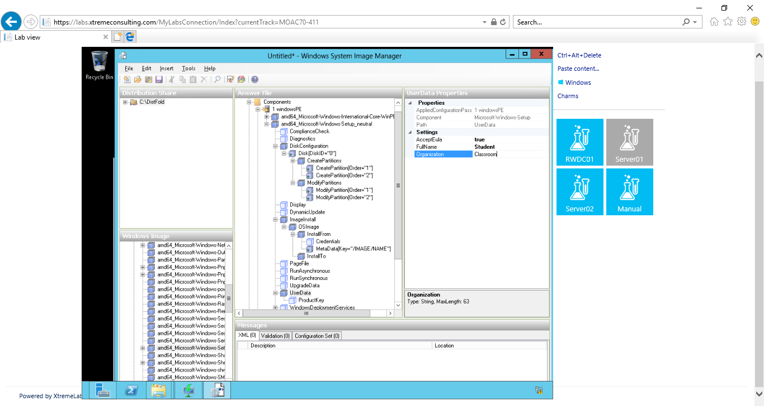

Figure Step 32. Expand UserData and click ProductKey. If you have a key, you type the Windows key in the Key box. For this lab, leave it blank.

**32.** Expand UserData and click ProductKey. If you have a key, you type the Windows key in the Key box. For this lab, leave it blank.

**33.** The Microsoft-Windows-Shell-Setup contains elements and settings that control how the shell of the Windows operating system is installed on a destination computer. In the Windows Image pane, right-click *amd64_Microsoft-Windows-Shell-Setup_6.2.9200.16384_neutral*, and click *Add Settings to Pass 4 specialize*.

**34.** In the Answer File pane, click on *amd64_Microsoft-Windows-Shell-Setup_neutral*. Here, you also enter the ProductKey. In addition, you can specify the ComputerName and TimeZone. For now, leave these blank.

**35.** In the Windows Image pane, right-click the *amd64_Microsoft-Windows-Shell-Setup_6.2.9200.16384_neutral*component and click *Add Settings to Pass 7 oobeSystem*.

**36.** In the Answer File pane, under *7 oobeSystem/amd64_Microsoft-Windows-Shell-Setup_neutral*, configure the following settings:

Registered Organization to **Classroom**

Registered Owner: **Student**

**37.** Open the File menu and select Save Answer File.

**38.** Browse to the C:\Software folder. For the File name text box, type **Unattend (Temp).xml** and click Save.

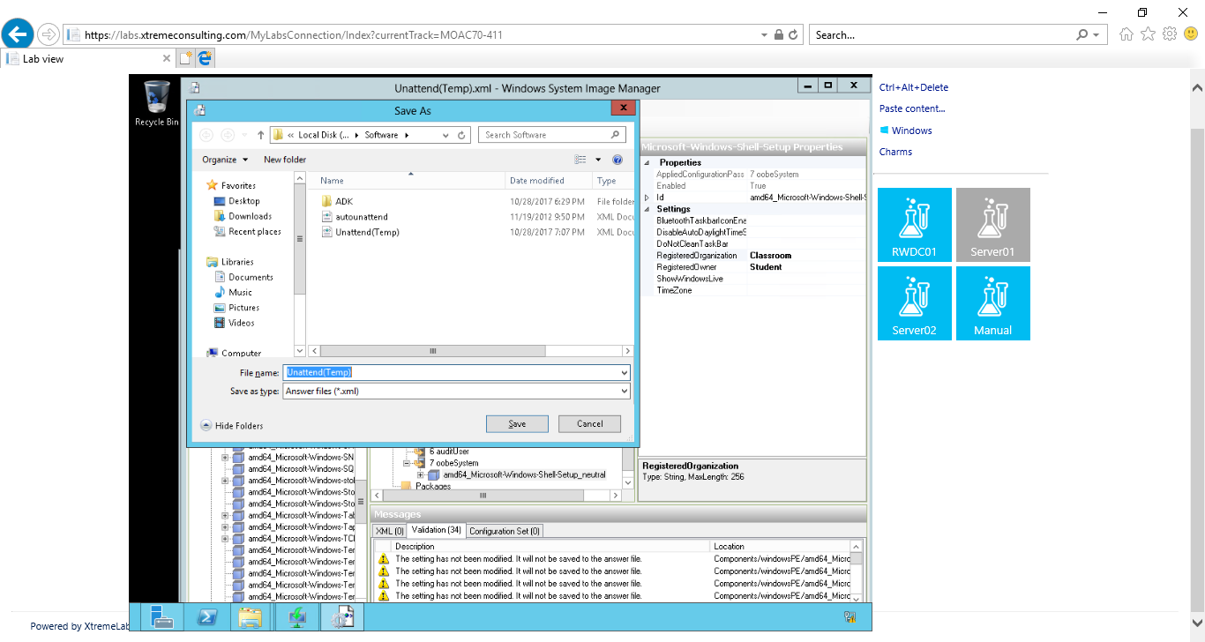**39.** Open the File menu and click Close Answer File.

Figure Step 38. Browse to the C:\Software folder. For the File name text box, type Unattend (Temp).xml and click Save.

# Step 2. Checking a Current Autounattend.xml File

**1.** On Server01, using Windows System Image Manager, open the File menu and click Open Answer File. Select the autounattend.xml from the C:\Software folder. Click Open.

**2.** Open the Tools menu and click Validate Answer File.

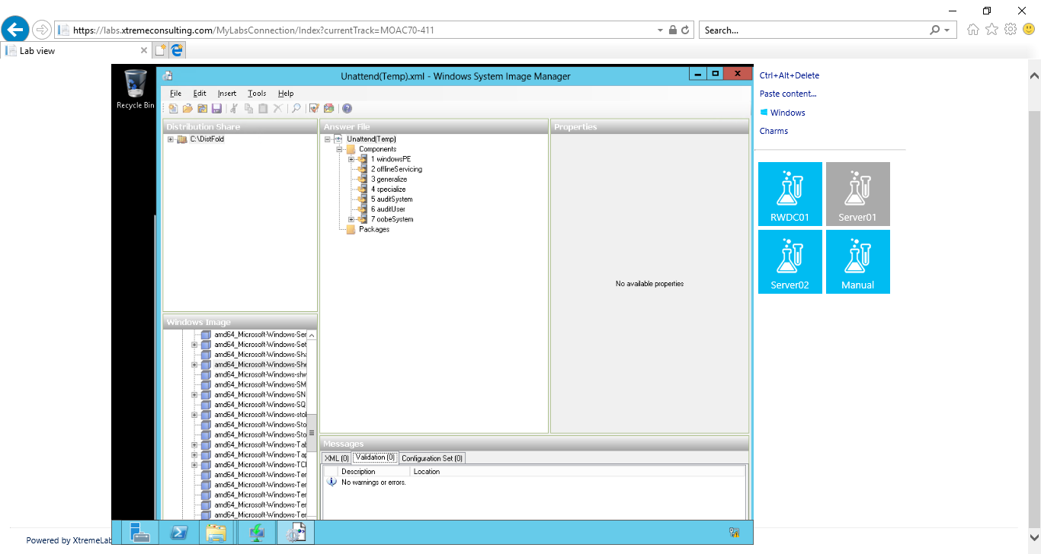**3.** In the Messages pane, make sure there are no errors. Warnings will appear, which are common.

Figure Step 2. Open the Tools menu and click Validate Answer File. No warnings or errors.

**4.** Take a screen shot of the Windows System Image Manager interface by pressing Alt+Prt Scr and then paste it into your Lab01_worksheet file in the page provided by pressing Ctrl+V.

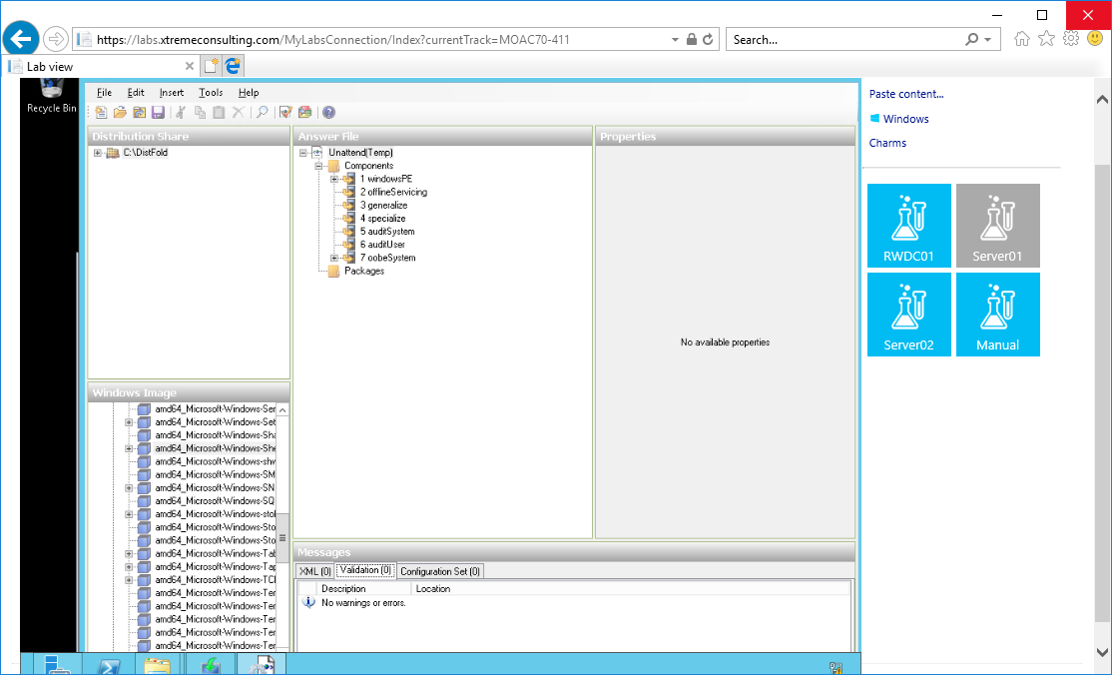

Figure Windows System Image Manager Interface

**5.** In the Answer File pane, expand the structure and view the various settings.

**6.** Close the Windows System Image Manager.

**7.** Open the C:\Softwarefolder.

**8.** Right-click the autounattend.xml file and click Open with and click Notepad.

**9.** Scroll through the document and review the various settings.

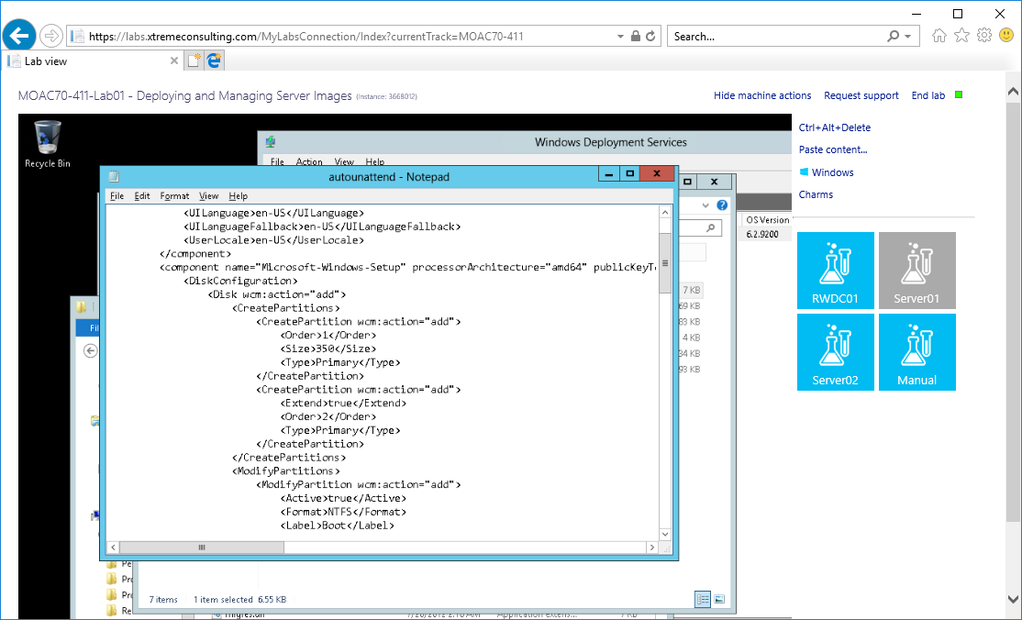**10.** Close Notepad.

Figure . autounattend.xml displayed in Notepad

**Lab Review Questions**

**What program did you use to create the unattend file?**

Windows System Image Manager was used to create the unattend file

**In Exercise 1.3, what program should you use to verify a unattend file?**

Validate Answer File in Tools in Windows System Image Manager.

**In Exercise 1.3, how was the Windows System Image Manager installed?**

From ADK

**Lab Summary**

If I install Windows using WDS, I will have to interact with the Windows installation program by choosing applicable settings during the installation process. In this lab, I learned how to create Autoattend.xml which can automate the installation and check a provided Autounattend.xml file.